TASK | Multi surface cleaner which can be used on all hard surfaces
LOCATION OF USE | Workshop and field engineers |  | Assessment  No |  | 009
PRODUCT NAME | XP10 |  |  |  | 009
DESCRIPTION OF SUBSTANCE | Cleaning Product |  |  |  | 009
MANUFACTURER | SEH Logistics |  |  |  | 009
MANUFACTURERS CONTACT | Unit FFB 9  Bonehill Farm  Tamworth  Staffordshire. B78 3HP  Tel: 07725 041331 |  |  |  | 009
ASSESSOR | Martin Monaghan CMIOSH |  | Date |  | 23 07 24
TITLE | Health and Safety Consultant |  | Review by |  | 23 07 26
Personnel Performing Task  (Please list below)  Technicians/ Fitters/ Workshop Operatives |  | Time Spent  (Minutes/day)  As and when required, amounting to a few minutes per day | Training Given 
 |  |  | Yes

MSDS Revision Date | Hazard Statement
04/07/2014 | H315 – Causes skin irritation.  H319 – Causes serious eye irritation

Assessment to be conducted in Association with Hazard Data Sheets, a full current copy of which must be attached to this assessment.

Please denote the hazardous properties of the substances used in the task with a

NEW INTERNATIONAL GLOBALLY HARMONISED HAZARD SYMBOLS
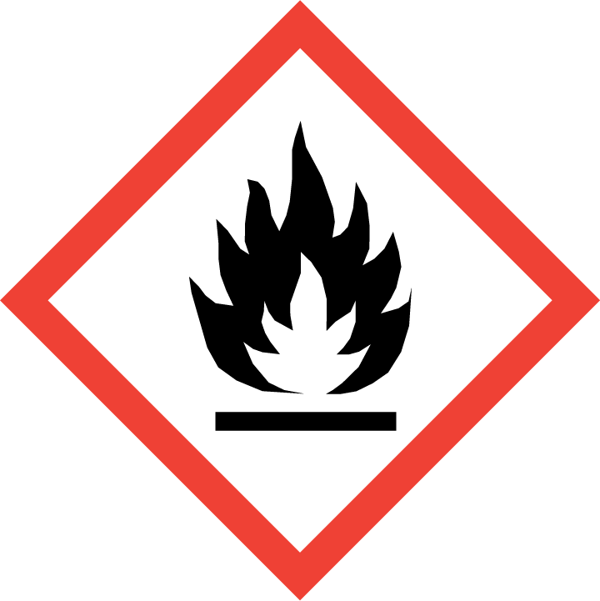 | 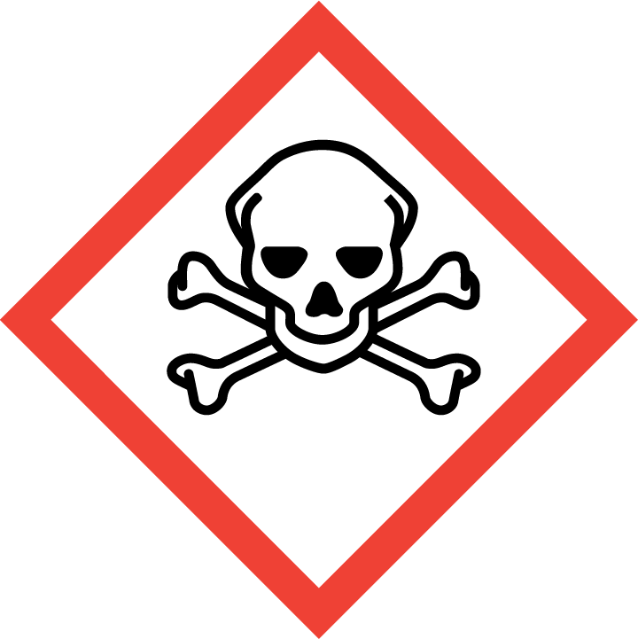 | 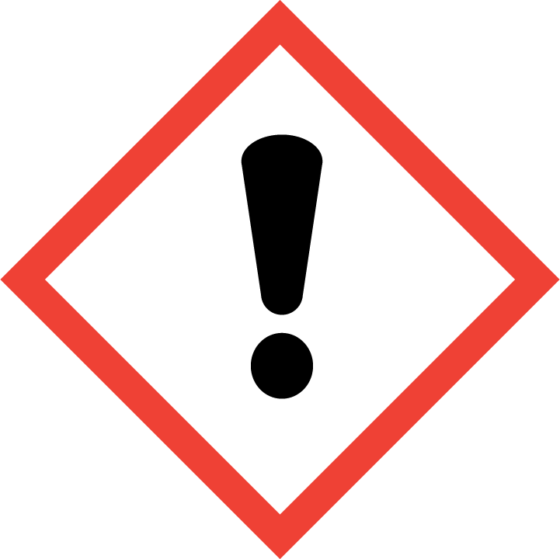 | 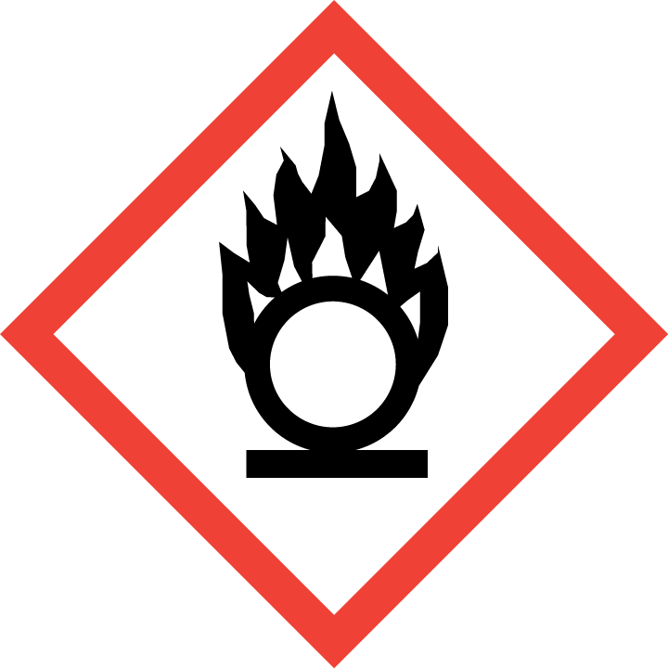 | 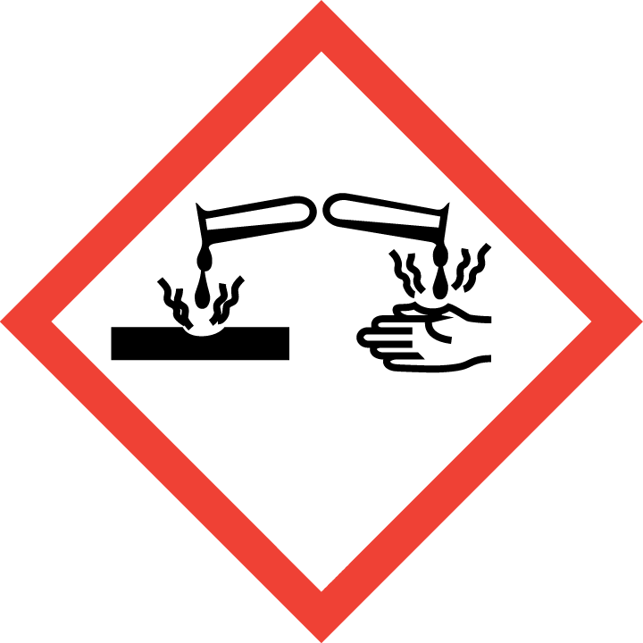 | 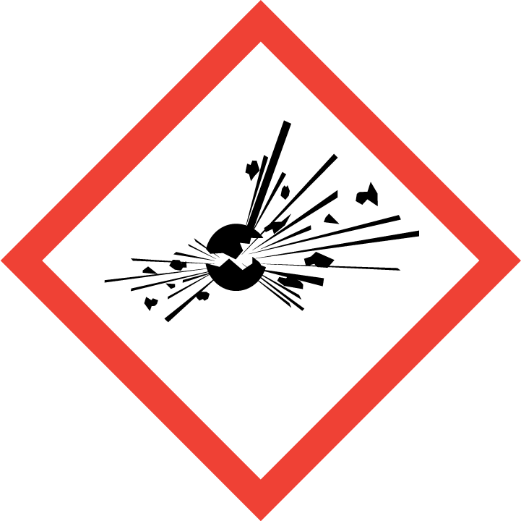 | 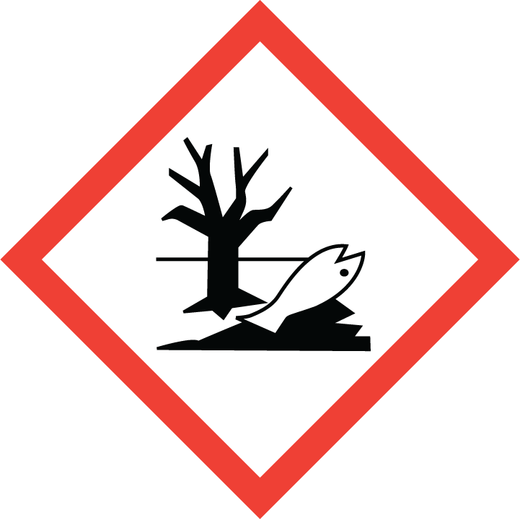 | 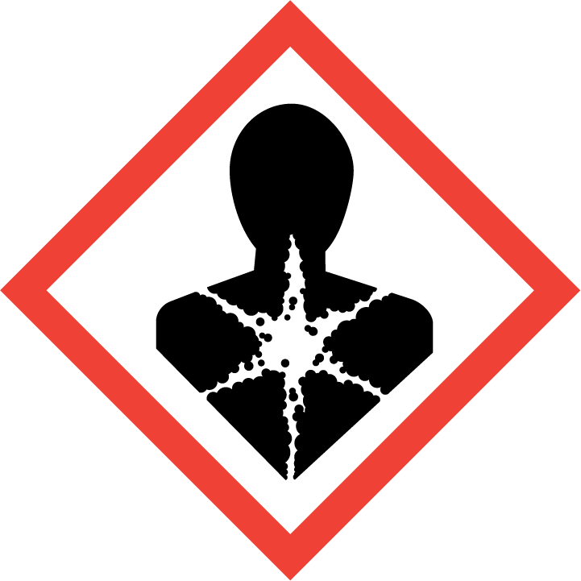
Flammable | Toxic | Harmful | Oxidising | Corrosive | Explosive | Harmful to the environment | Health Hazards i.e. respiratory sensitisation or carcinogenicity

SMOKING, EATING AND DRINKING ARE PROHIBITED IN THE WORK AREAS.
Information, Instruction and Training must be provided to all users. Young Persons, New or Expectant Mothers and other vulnerable groups must not use or be exposed to this product.

WORKPLACE EXPOSURE LIMITS (WEL’s)
No occupational exposure limits assigned for this product.

IMPORTANT!
Refer to Workplace Exposure Levels information provided in the Manufacturers Safety Data and revise control measures if exposure levels likely to be reached.

ROUTE OF EXPOSURE
Skin |  | Eyes |  | Inhalation
Ingestion |  | Cuts/abrasions |  | Systemic

PERSONS AT RISK
User of product |  | Co workers |  | Members of the public

ROUTE OF EXPOSURE |   FIRST AID MEASURES
Inhalation | Move the exposed person to fresh air at once. Rinse nose and mouth with water. Get medical attention if  any discomfort continues.
Skin contact | Remove affected person from source of contamination. Remove contaminated clothing. Wash the skin  immediately with soap and water. Get medical attention if any discomfort continues.
Eye contact | Make sure to remove any contact lenses from the eyes before rinsing. Promptly wash eyes with plenty of  water while lifting the eye lids. Continue to rinse for at least 15 minutes. Get medical attention if any  discomfort continues.
Swallowing | Immediately rinse mouth and provide fresh air. Get medical attention if any discomfort continues. Do not  induce vomiting.
In all cases of doubt, or if symptoms persist seek medical attention. Never give anything by mouth to an unconscious person. If unconscious, place in recovery position and seek medical advice.

PERSONAL PROTECTIVE EQUIPMENT
 |  |  |  | 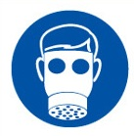 |  | 
YES | YES | YES/NO |  | YES/NO | YES | YES/NO
YES | YES |  |  |  | YES - Chemical Resistant

HANDLING | STORAGE | TRANSPORT | DISPOSAL
Always wash hands after handling. Avoid skin and eye contact with this mixture. | Store between 4°C and 25°C in a dry, well ventilated place. Keep the container tightly closed in a dry, well‐ventilated place | Carry secured upright with lid on. Only used on site with pressure washer | Must not be disposed of with household waste. Used, degraded or contaminated product may be classified as hazardous waste. Return empty aerosols to the factory for disposal.

REQUIRED CONTROL MEASURES
- Ensure only minimum amounts of multi surface cleaner are stored on site.
- Ensure approved impermeable gloves are used at all times.
- Ensure overalls are worn and these are suitably laundered.
- Ensure that work is undertaken in well ventilated areas.
- Ensure that Engineers are equipped with antibacterial hand washes and wipes and that good hygiene practices are enforced.
- Provide engineers with suitable barrier creams.

FIRE PRECAUTIONS
This product is not flammable. Use fire-extinguishing media appropriate for surrounding materials.

ACCIDENTAL RELEASE/SPILLAGE PROCEDURES
Avoid any contact with the skin and eyes. If a large quantity has been spilt, evacuate all personnel and only allow intervention by trained operators equipped with safety apparatus.

MONITORING REQUIREMENTS AND HEALTH SURVEILLANCE
Health surveillance is not in place for workers exposed to this product.

